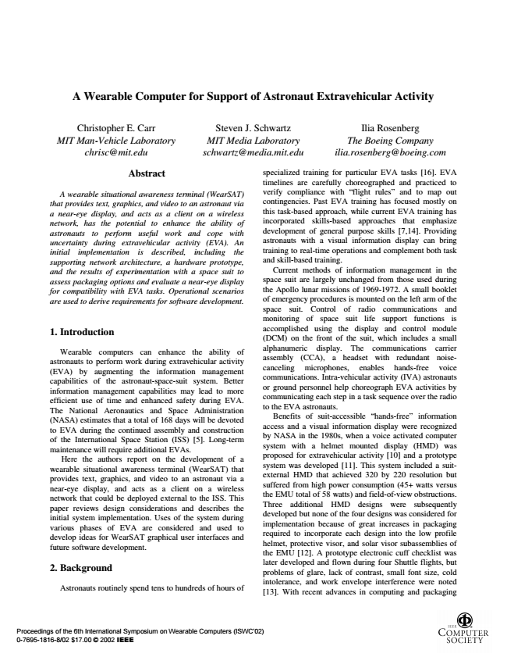

Proceedings of the 6th International Symposium on Wearable Computers (ISWC‘02) 0-7695-1816-8/02 $17.00 © 2002 IEEE

**A Wearable Computer for Support of Astronaut Extravehicular Activity**

*Christopher E. Carr MIT Man-Vehicle Laboratory chrisc@mit.edu*

*Steven J. Schwartz MIT Media Laboratory schwartz@media.mit.edu*

*Ilia Rosenberg The Boeing Company ilia.rosenberg@boeing.com*

**Abstract**

*A wearable situational awareness terminal (WearSAT) that provides text, graphics, and video to an astronaut via a near-eye display, and acts as a client on a wireless network, has the potential to enhance the ability of astronauts to perform useful work and cope with uncertainty during extravehicular activity (EVA). An initial implementation is described, including the supporting network architecture, a hardware prototype, and the results of experimentation with a space suit to assess packaging options and evaluate a near-eye display for compatibility with EVA tasks. Operational scenarios are used to derive requirements for software development.*

**1. Introduction**

Wearable computers can enhance the ability of astronauts to perform work during extravehicular activity (EVA) by augmenting the information management capabilities of the astronaut-space-suit system. Better information management capabilities may lead to more efficient use of time and enhanced safety during EVA. The National Aeronautics and Space Administration (NASA) estimates that a total of 168 days will be devoted to EVA during the continued assembly and construction of the International Space Station (ISS) [5]. Long-term maintenance will require additional EVAs.

Here the authors report on the development of a wearable situational awareness terminal (WearSAT) that provides text, graphics, and video to an astronaut via a near-eye display, and acts as a client on a wireless network that could be deployed external to the ISS. This paper reviews design considerations and describes the initial system implementation. Uses of the system during various phases of EVA are considered and used to develop ideas for WearSAT graphical user interfaces and future software development.

**2. Background**

Astronauts routinely spend tens to hundreds of hours of

specialized training for particular EVA tasks [16]. EVA timelines are carefully choreographed and practiced to verify compliance with “flight rules” and to map out contingencies. Past EVA training has focused mostly on this task-based approach, while current EVA training has incorporated skills-based approaches that emphasize development of general purpose skills [7,14]. Providing astronauts with a visual information display can bring training to real-time operations and complement both task and skill-based training.

Current methods of information management in the space suit are largely unchanged from those used during the Apollo lunar missions of 1969-1972. A small booklet of emergency procedures is mounted on the left arm of the space suit. Control of radio communications and monitoring of space suit life support functions is accomplished using the display and control module (DCM) on the front of the suit, which includes a small alphanumeric display. The communications carrier assembly (CCA), a headset with redundant noise- canceling microphones, enables hands-free voice communications. Intra-vehicular activity (IVA) astronauts or ground personnel help choreograph EVA activities by communicating each step in a task sequence over the radio to the EVA astronauts.

Benefits of suit-accessible “hands-free” information access and a visual information display were recognized by NASA in the 1980s, when a voice activated computer system with a helmet mounted display (HMD) was proposed for extravehicular activity [10] and a prototype system was developed [11]. This system included a suit- external HMD that achieved 320 by 220 resolution but suffered from high power consumption (45+ watts versus the EMU total of 58 watts) and field-of-view obstructions. Three additional HMD designs were subsequently developed but none of the four designs was considered for implementation because of great increases in packaging required to incorporate each design into the low profile helmet, protective visor, and solar visor subassemblies of the EMU [12]. A prototype electronic cuff checklist was later developed and flown during four Shuttle flights, but problems of glare, lack of contrast, small font size, cold intolerance, and work envelope interference were noted [13]. With recent advances in computing and packaging

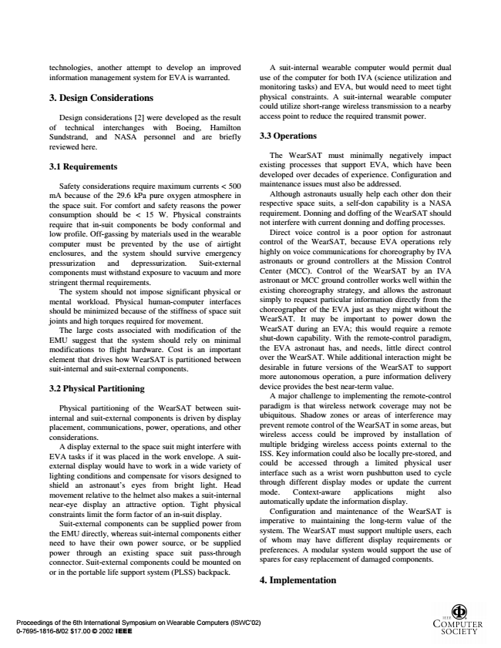

Proceedings of the 6th International Symposium on Wearable Computers (ISWC‘02) 0-7695-1816-8/02 $17.00 © 2002 IEEE

technologies, another attempt to develop an improved information management system for EVA is warranted.

**3. Design Considerations**

Design considerations [2] were developed as the result of technical interchanges with Boeing, Hamilton Sundstrand, and NASA personnel and are briefly reviewed here.

**3.1 Requirements**

Safety considerations require maximum currents < 500 mA because of the 29.6 kPa pure oxygen atmosphere in the space suit. For comfort and safety reasons the power consumption should be < 15 W. Physical constraints require that in-suit components be body conformal and low profile. Off-gassing by materials used in the wearable computer must be prevented by the use of airtight enclosures, and the system should survive emergency pressurization and depressurization. Suit-external components must withstand exposure to vacuum and more stringent thermal requirements.

The system should not impose significant physical or mental workload. Physical human-computer interfaces should be minimized because of the stiffness of space suit joints and high torques required for movement.

The large costs associated with modification of the EMU suggest that the system should rely on minimal modifications to flight hardware. Cost is an important element that drives how WearSAT is partitioned between suit-internal and suit-external components.

**3.2 Physical Partitioning**

Physical partitioning of the WearSAT between suit- internal and suit-external components is driven by display placement, communications, power, operations, and other considerations.

A display external to the space suit might interfere with EVA tasks if it was placed in the work envelope. A suit- external display would have to work in a wide variety of lighting conditions and compensate for visors designed to shield an astronaut’s eyes from bright light. Head movement relative to the helmet also makes a suit-internal near-eye display an attractive option. Tight physical constraints limit the form factor of an in-suit display.

Suit-external components can be supplied power from the EMU directly, whereas suit-internal components either need to have their own power source, or be supplied power through an existing space suit pass-through connector. Suit-external components could be mounted on or in the portable life support system (PLSS) backpack.

A suit-internal wearable computer would permit dual use of the computer for both IVA (science utilization and monitoring tasks) and EVA, but would need to meet tight physical constraints. A suit-internal wearable computer could utilize short-range wireless transmission to a nearby access point to reduce the required transmit power.

**3.3 Operations**

The WearSAT must minimally negatively impact existing processes that support EVA, which have been developed over decades of experience. Configuration and maintenance issues must also be addressed.

Although astronauts usually help each other don their respective space suits, a self-don capability is a NASA requirement. Donning and doffing of the WearSAT should not interfere with current donning and doffing processes.

Direct voice control is a poor option for astronaut control of the WearSAT, because EVA operations rely highly on voice communications for choreography by IVA astronauts or ground controllers at the Mission Control Center (MCC). Control of the WearSAT by an IVA astronaut or MCC ground controller works well within the existing choreography strategy, and allows the astronaut simply to request particular information directly from the choreographer of the EVA just as they might without the WearSAT. It may be important to power down the WearSAT during an EVA; this would require a remote shut-down capability. With the remote-control paradigm, the EVA astronaut has, and needs, little direct control over the WearSAT. While additional interaction might be desirable in future versions of the WearSAT to support more autonomous operation, a pure information delivery device provides the best near-term value.

A major challenge to implementing the remote-control paradigm is that wireless network coverage may not be ubiquitous. Shadow zones or areas of interference may prevent remote control of the WearSAT in some areas, but wireless access could be improved by installation of multiple bridging wireless access points external to the ISS. Key information could also be locally pre-stored, and could be accessed through a limited physical user interface such as a wrist worn pushbutton used to cycle through different display modes or update the current mode. Context-aware applications might also automatically update the information display.

Configuration and maintenance of the WearSAT is imperative to maintaining the long-term value of the system. The WearSAT must support multiple users, each of whom may have different display requirements or preferences. A modular system would support the use of spares for easy replacement of damaged components.

**4. Implementation**

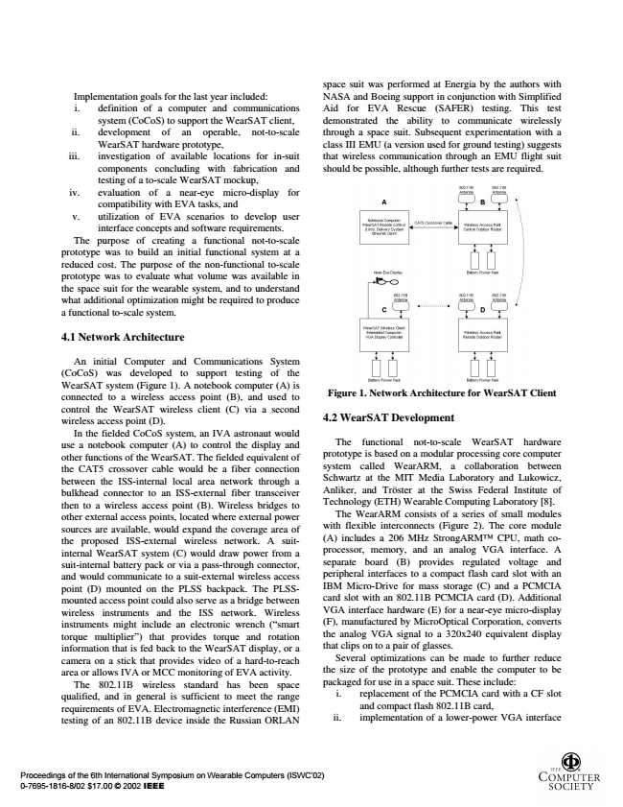

Proceedings of the 6th International Symposium on Wearable Computers (ISWC‘02) 0-7695-1816-8/02 $17.00 © 2002 IEEE

Implementation goals for the last year included: i. definition of a computer and communications

system (CoCoS) to support the WearSAT client, ii. development of an operable, not-to-scale

WearSAT hardware prototype, iii. investigation of available locations for in-suit components concluding with fabrication and testing of a to-scale WearSAT mockup, iv. evaluation of a near-eye micro-display for

compatibility with EVA tasks, and v. utilization of EVA scenarios to develop user

interface concepts and software requirements. The purpose of creating a functional not-to-scale prototype was to build an initial functional system at a reduced cost. The purpose of the non-functional to-scale prototype was to evaluate what volume was available in the space suit for the wearable system, and to understand what additional optimization might be required to produce a functional to-scale system.

**4.1 Network Architecture**

An initial Computer and Communications System (CoCoS) was developed to support testing of the WearSAT system (Figure 1). A notebook computer (A) is connected to a wireless access point (B), and used to control the WearSAT wireless client (C) via a second wireless access point (D).

In the fielded CoCoS system, an IVA astronaut would use a notebook computer (A) to control the display and other functions of the WearSAT. The fielded equivalent of the CAT5 crossover cable would be a fiber connection between the ISS-internal local area network through a bulkhead connector to an ISS-external fiber transceiver then to a wireless access point (B). Wireless bridges to other external access points, located where external power sources are available, would expand the coverage area of the proposed ISS-external wireless network. A suit- internal WearSAT system (C) would draw power from a suit-internal battery pack or via a pass-through connector, and would communicate to a suit-external wireless access point (D) mounted on the PLSS backpack. The PLSS- mounted access point could also serve as a bridge between wireless instruments and the ISS network. Wireless instruments might include an electronic wrench (“smart torque multiplier”) that provides torque and rotation information that is fed back to the WearSAT display, or a camera on a stick that provides video of a hard-to-reach area or allows IVA or MCC monitoring of EVA activity.

The 802.11B wireless standard has been space qualified, and in general is sufficient to meet the range requirements of EVA. Electromagnetic interference (EMI) testing of an 802.11B device inside the Russian ORLAN

space suit was performed at Energia by the authors with NASA and Boeing support in conjunction with Simplified Aid for EVA Rescue (SAFER) testing. This test demonstrated the ability to communicate wirelessly through a space suit. Subsequent experimentation with a class III EMU (a version used for ground testing) suggests that wireless communication through an EMU flight suit should be possible, although further tests are required.

**Figure 1. Network Architecture for WearSAT Client**

**4.2 WearSAT Development**

The functional not-to-scale WearSAT hardware prototype is based on a modular processing core computer system called WearARM, a collaboration between Schwartz at the MIT Media Laboratory and Lukowicz, Anliker, and Tröster at the Swiss Federal Institute of Technology (ETH) Wearable Computing Laboratory [8].

The WearARM consists of a series of small modules with flexible interconnects (Figure 2). The core module (A) includes a 206 MHz StrongARMTM CPU, math co- processor, memory, and an analog VGA interface. A separate board (B) provides regulated voltage and peripheral interfaces to a compact flash card slot with an IBM Micro-Drive for mass storage (C) and a PCMCIA card slot with an 802.11B PCMCIA card (D). Additional VGA interface hardware (E) for a near-eye micro-display (F), manufactured by MicroOptical Corporation, converts the analog VGA signal to a 320x240 equivalent display that clips on to a pair of glasses.

Several optimizations can be made to further reduce the size of the prototype and enable the computer to be packaged for use in a space suit. These include:

i. replacement of the PCMCIA card with a CF slot

and compact flash 802.11B card, ii. implementation of a lower-power VGA interface

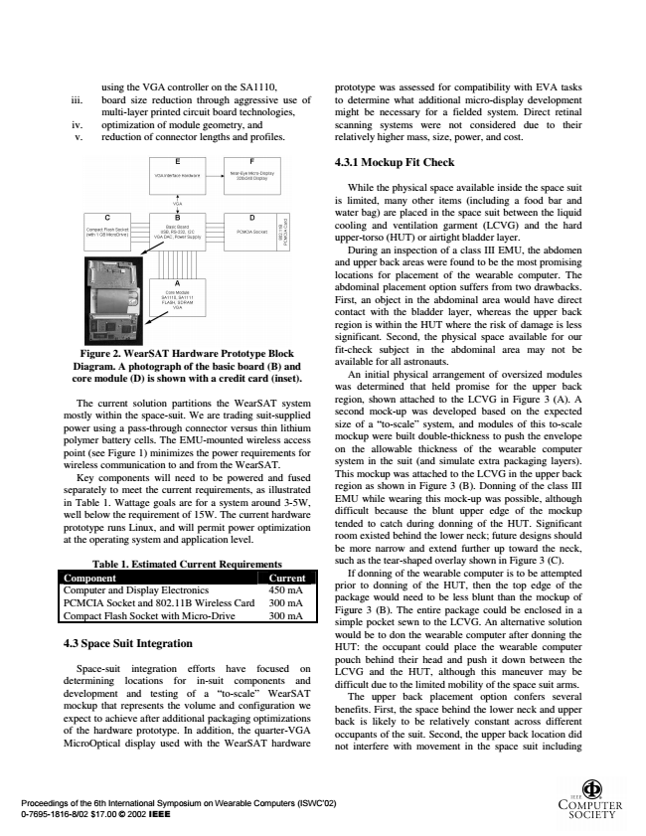

Proceedings of the 6th International Symposium on Wearable Computers (ISWC‘02) 0-7695-1816-8/02 $17.00 © 2002 IEEE

**Figure 2. WearSAT Hardware Prototype Block Diagram. A photograph of the basic board (B) and core module (D) is shown with a credit card (inset).**

The current solution partitions the WearSAT system mostly within the space-suit. We are trading suit-supplied power using a pass-through connector versus thin lithium polymer battery cells. The EMU-mounted wireless access point (see Figure 1) minimizes the power requirements for wireless communication to and from the WearSAT.

Key components will need to be powered and fused separately to meet the current requirements, as illustrated in Table 1. Wattage goals are for a system around 3-5W, well below the requirement of 15W. The current hardware prototype runs Linux, and will permit power optimization at the operating system and application level.

Table 1. Estimated Current Requirements Component Current Computer and Display Electronics 450 mA PCMCIA Socket and 802.11B Wireless Card 300 mA Compact Flash Socket with Micro-Drive 300 mA

**4.3 Space Suit Integration**

Space-suit integration efforts have focused on determining locations for in-suit components and development and testing of a “to-scale” WearSAT mockup that represents the volume and configuration we expect to achieve after additional packaging optimizations of the hardware prototype. In addition, the quarter-VGA MicroOptical display used with the WearSAT hardware

using the VGA controller on the SA1110, iii. board size reduction through aggressive use of

multi-layer printed circuit board technologies, iv. optimization of module geometry, and

v. reduction of connector lengths and profiles.

prototype was assessed for compatibility with EVA tasks to determine what additional micro-display development might be necessary for a fielded system. Direct retinal scanning systems were not considered due to their relatively higher mass, size, power, and cost.

**4.3.1 Mockup Fit Check**

While the physical space available inside the space suit is limited, many other items (including a food bar and water bag) are placed in the space suit between the liquid cooling and ventilation garment (LCVG) and the hard upper-torso (HUT) or airtight bladder layer.

During an inspection of a class III EMU, the abdomen and upper back areas were found to be the most promising locations for placement of the wearable computer. The abdominal placement option suffers from two drawbacks. First, an object in the abdominal area would have direct contact with the bladder layer, whereas the upper back region is within the HUT where the risk of damage is less significant. Second, the physical space available for our fit-check subject in the abdominal area may not be available for all astronauts.

An initial physical arrangement of oversized modules was determined that held promise for the upper back region, shown attached to the LCVG in Figure 3 (A). A second mock-up was developed based on the expected size of a “to-scale” system, and modules of this to-scale mockup were built double-thickness to push the envelope on the allowable thickness of the wearable computer system in the suit (and simulate extra packaging layers). This mockup was attached to the LCVG in the upper back region as shown in Figure 3 (B). Donning of the class III EMU while wearing this mock-up was possible, although difficult because the blunt upper edge of the mockup tended to catch during donning of the HUT. Significant room existed behind the lower neck; future designs should be more narrow and extend further up toward the neck, such as the tear-shaped overlay shown in Figure 3 (C).

If donning of the wearable computer is to be attempted prior to donning of the HUT, then the top edge of the package would need to be less blunt than the mockup of Figure 3 (B). The entire package could be enclosed in a simple pocket sewn to the LCVG. An alternative solution would be to don the wearable computer after donning the HUT: the occupant could place the wearable computer pouch behind their head and push it down between the LCVG and the HUT, although this maneuver may be difficult due to the limited mobility of the space suit arms.

The upper back placement option confers several benefits. First, the space behind the lower neck and upper back is likely to be relatively constant across different occupants of the suit. Second, the upper back location did not interfere with movement in the space suit including

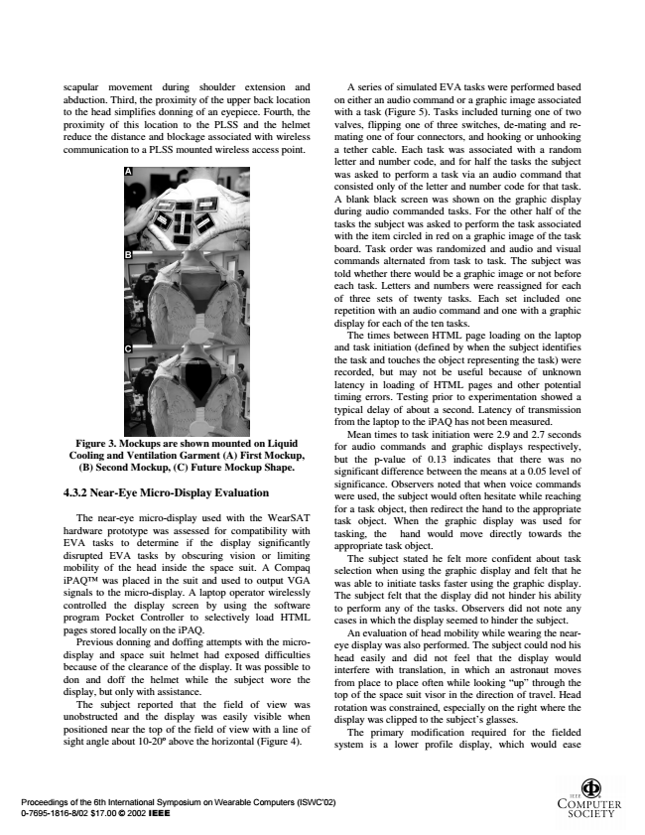

Proceedings of the 6th International Symposium on Wearable Computers (ISWC‘02) 0-7695-1816-8/02 $17.00 © 2002 IEEE

scapular movement during shoulder extension and abduction. Third, the proximity of the upper back location to the head simplifies donning of an eyepiece. Fourth, the proximity of this location to the PLSS and the helmet reduce the distance and blockage associated with wireless communication to a PLSS mounted wireless access point.

**Figure 3. Mockups are shown mounted on Liquid Cooling and Ventilation Garment (A) First Mockup, (B) Second Mockup, (C) Future Mockup Shape.**

**4.3.2 Near-Eye Micro-Display Evaluation**

The near-eye micro-display used with the WearSAT hardware prototype was assessed for compatibility with EVA tasks to determine if the display significantly disrupted EVA tasks by obscuring vision or limiting mobility of the head inside the space suit. A Compaq iPAQTM was placed in the suit and used to output VGA signals to the micro-display. A laptop operator wirelessly controlled the display screen by using the software program Pocket Controller to selectively load HTML pages stored locally on the iPAQ.

Previous donning and doffing attempts with the micro- display and space suit helmet had exposed difficulties because of the clearance of the display. It was possible to don and doff the helmet while the subject wore the display, but only with assistance.

The subject reported that the field of view was unobstructed and the display was easily visible when positioned near the top of the field of view with a line of sight angle about 10-20o above the horizontal (Figure 4).

A series of simulated EVA tasks were performed based on either an audio command or a graphic image associated with a task (Figure 5). Tasks included turning one of two valves, flipping one of three switches, de-mating and re- mating one of four connectors, and hooking or unhooking a tether cable. Each task was associated with a random letter and number code, and for half the tasks the subject was asked to perform a task via an audio command that consisted only of the letter and number code for that task. A blank black screen was shown on the graphic display during audio commanded tasks. For the other half of the tasks the subject was asked to perform the task associated with the item circled in red on a graphic image of the task board. Task order was randomized and audio and visual commands alternated from task to task. The subject was told whether there would be a graphic image or not before each task. Letters and numbers were reassigned for each of three sets of twenty tasks. Each set included one repetition with an audio command and one with a graphic display for each of the ten tasks.

The times between HTML page loading on the laptop and task initiation (defined by when the subject identifies the task and touches the object representing the task) were recorded, but may not be useful because of unknown latency in loading of HTML pages and other potential timing errors. Testing prior to experimentation showed a typical delay of about a second. Latency of transmission from the laptop to the iPAQ has not been measured.

Mean times to task initiation were 2.9 and 2.7 seconds for audio commands and graphic displays respectively, but the p-value of 0.13 indicates that there was no significant difference between the means at a 0.05 level of significance. Observers noted that when voice commands were used, the subject would often hesitate while reaching for a task object, then redirect the hand to the appropriate task object. When the graphic display was used for tasking, the hand would move directly towards the appropriate task object.

The subject stated he felt more confident about task selection when using the graphic display and felt that he was able to initiate tasks faster using the graphic display. The subject felt that the display did not hinder his ability to perform any of the tasks. Observers did not note any cases in which the display seemed to hinder the subject.

An evaluation of head mobility while wearing the near- eye display was also performed. The subject could nod his head easily and did not feel that the display would interfere with translation, in which an astronaut moves from place to place often while looking “up” through the top of the space suit visor in the direction of travel. Head rotation was constrained, especially on the right where the display was clipped to the subject’s glasses.

The primary modification required for the fielded system is a lower profile display, which would ease

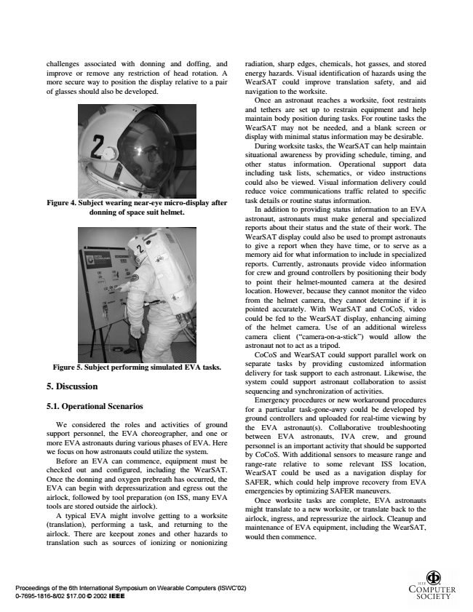

Proceedings of the 6th International Symposium on Wearable Computers (ISWC‘02) 0-7695-1816-8/02 $17.00 © 2002 IEEE

challenges associated with donning and doffing, and improve or remove any restriction of head rotation. A more secure way to position the display relative to a pair of glasses should also be developed.

**Figure 5. Subject performing simulated EVA tasks.**

**5. Discussion**

**5.1. Operational Scenarios**

We considered the roles and activities of ground support personnel, the EVA choreographer, and one or more EVA astronauts during various phases of EVA. Here we focus on how astronauts could utilize the system.

Before an EVA can commence, equipment must be checked out and configured, including the WearSAT. Once the donning and oxygen prebreath has occurred, the EVA can begin with depressurization and egress out the airlock, followed by tool preparation (on ISS, many EVA tools are stored outside the airlock).

A typical EVA might involve getting to a worksite (translation), performing a task, and returning to the airlock. There are keepout zones and other hazards to translation such as sources of ionizing or nonionizing

**Figure 4. Subject wearing near-eye micro-display after donning of space suit helmet.**

radiation, sharp edges, chemicals, hot gasses, and stored energy hazards. Visual identification of hazards using the WearSAT could improve translation safety, and aid navigation to the worksite.

Once an astronaut reaches a worksite, foot restraints and tethers are set up to restrain equipment and help maintain body position during tasks. For routine tasks the WearSAT may not be needed, and a blank screen or display with minimal status information may be desirable.

During worksite tasks, the WearSAT can help maintain situational awareness by providing schedule, timing, and other status information. Operational support data including task lists, schematics, or video instructions could also be viewed. Visual information delivery could reduce voice communications traffic related to specific task details or routine status information.

In addition to providing status information to an EVA astronaut, astronauts must make general and specialized reports about their status and the state of their work. The WearSAT display could also be used to prompt astronauts to give a report when they have time, or to serve as a memory aid for what information to include in specialized reports. Currently, astronauts provide video information for crew and ground controllers by positioning their body to point their helmet-mounted camera at the desired location. However, because they cannot monitor the video from the helmet camera, they cannot determine if it is pointed accurately. With WearSAT and CoCoS, video could be fed to the WearSAT display, enhancing aiming of the helmet camera. Use of an additional wireless camera client (“camera-on-a-stick”) would allow the astronaut not to act as a tripod.

CoCoS and WearSAT could support parallel work on separate tasks by providing customized information delivery for task support to each astronaut. Likewise, the system could support astronaut collaboration to assist sequencing and synchronization of activities.

Emergency procedures or new workaround procedures for a particular task-gone-awry could be developed by ground controllers and uploaded for real-time viewing by the EVA astronaut(s). Collaborative troubleshooting between EVA astronauts, IVA crew, and ground personnel is an important activity that should be supported by CoCoS. With additional sensors to measure range and range-rate relative to some relevant ISS location, WearSAT could be used as a navigation display for SAFER, which could help improve recovery from EVA emergencies by optimizing SAFER maneuvers.

Once worksite tasks are complete, EVA astronauts might translate to a new worksite, or translate back to the airlock, ingress, and repressurize the airlock. Cleanup and maintenance of EVA equipment, including the WearSAT, would then commence.

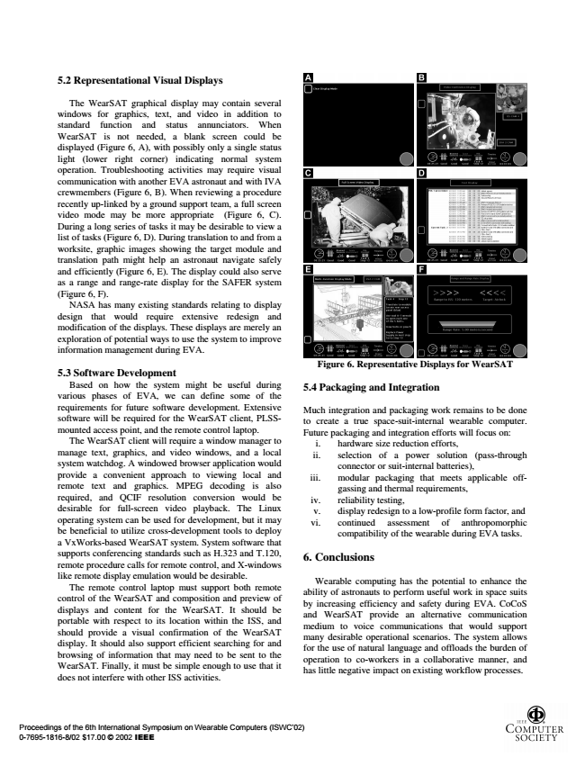

Proceedings of the 6th International Symposium on Wearable Computers (ISWC‘02) 0-7695-1816-8/02 $17.00 © 2002 IEEE

**5.2 Representational Visual Displays**

The WearSAT graphical display may contain several windows for graphics, text, and video in addition to standard function and status annunciators. When WearSAT is not needed, a blank screen could be displayed (Figure 6, A), with possibly only a single status light (lower right corner) indicating normal system operation. Troubleshooting activities may require visual communication with another EVA astronaut and with IVA crewmembers (Figure 6, B). When reviewing a procedure recently up-linked by a ground support team, a full screen video mode may be more appropriate (Figure 6, C). During a long series of tasks it may be desirable to view a list of tasks (Figure 6, D). During translation to and from a worksite, graphic images showing the target module and translation path might help an astronaut navigate safely and efficiently (Figure 6, E). The display could also serve as a range and range-rate display for the SAFER system (Figure 6, F).

NASA has many existing standards relating to display design that would require extensive redesign and modification of the displays. These displays are merely an exploration of potential ways to use the system to improve information management during EVA.

**5.3 Software Development**

Based on how the system might be useful during various phases of EVA, we can define some of the requirements for future software development. Extensive software will be required for the WearSAT client, PLSS- mounted access point, and the remote control laptop.

The WearSAT client will require a window manager to manage text, graphics, and video windows, and a local system watchdog. A windowed browser application would provide a convenient approach to viewing local and remote text and graphics. MPEG decoding is also required, and QCIF resolution conversion would be desirable for full-screen video playback. The Linux operating system can be used for development, but it may be beneficial to utilize cross-development tools to deploy a VxWorks-based WearSAT system. System software that supports conferencing standards such as H.323 and T.120, remote procedure calls for remote control, and X-windows like remote display emulation would be desirable.

The remote control laptop must support both remote control of the WearSAT and composition and preview of displays and content for the WearSAT. It should be portable with respect to its location within the ISS, and should provide a visual confirmation of the WearSAT display. It should also support efficient searching for and browsing of information that may need to be sent to the WearSAT. Finally, it must be simple enough to use that it does not interfere with other ISS activities.

**Figure 6. Representative Displays for WearSAT**

**5.4 Packaging and Integration**

Much integration and packaging work remains to be done to create a true space-suit-internal wearable computer. Future packaging and integration efforts will focus on:

i. hardware size reduction efforts, ii. selection of a power solution (pass-through

connector or suit-internal batteries), iii. modular packaging that meets applicable off-

gassing and thermal requirements, iv. reliability testing,

v. display redesign to a low-profile form factor, and vi. continued assessment of anthropomorphic

compatibility of the wearable during EVA tasks.

**6. Conclusions**

Wearable computing has the potential to enhance the ability of astronauts to perform useful work in space suits by increasing efficiency and safety during EVA. CoCoS and WearSAT provide an alternative communication medium to voice communications that would support many desirable operational scenarios. The system allows for the use of natural language and offloads the burden of operation to co-workers in a collaborative manner, and has little negative impact on existing workflow processes.

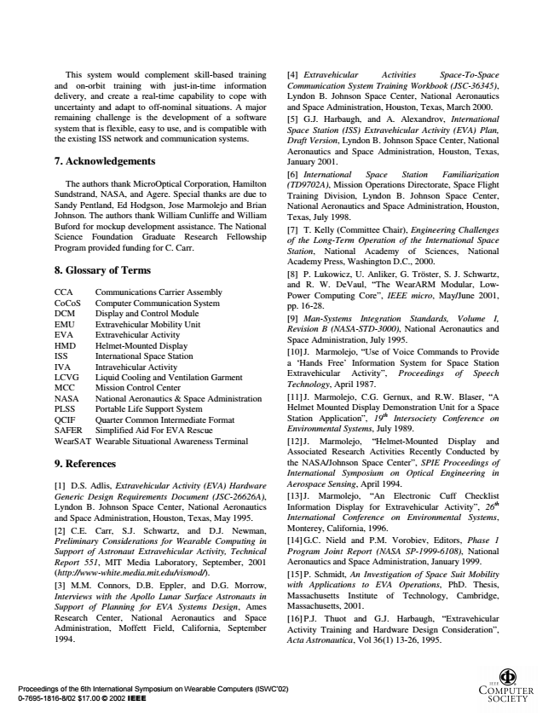

Proceedings of the 6th International Symposium on Wearable Computers (ISWC‘02) 0-7695-1816-8/02 $17.00 © 2002 IEEE

This system would complement skill-based training and on-orbit training with just-in-time information delivery, and create a real-time capability to cope with uncertainty and adapt to off-nominal situations. A major remaining challenge is the development of a software system that is flexible, easy to use, and is compatible with the existing ISS network and communication systems.

**7. Acknowledgements**

The authors thank MicroOptical Corporation, Hamilton Sundstrand, NASA, and Agere. Special thanks are due to Sandy Pentland, Ed Hodgson, Jose Marmolejo and Brian Johnson. The authors thank William Cunliffe and William Buford for mockup development assistance. The National Science Foundation Graduate Research Fellowship Program provided funding for C. Carr.

**8. Glossary of Terms**

CCA Communications Carrier Assembly CoCoS Computer Communication System DCM Display and Control Module EMU Extravehicular Mobility Unit EVA Extravehicular Activity HMD Helmet-Mounted Display ISS International Space Station IVA Intravehicular Activity LCVG Liquid Cooling and Ventilation Garment MCC Mission Control Center NASA National Aeronautics & Space Administration PLSS Portable Life Support System QCIF Quarter Common Intermediate Format SAFER Simplified Aid For EVA Rescue WearSAT Wearable Situational Awareness Terminal

**9. References**

[1] D.S. Adlis, Extravehicular Activity (EVA) Hardware Generic Design Requirements Document (JSC-26626A), Lyndon B. Johnson Space Center, National Aeronautics and Space Administration, Houston, Texas, May 1995. [2] C.E. Carr, S.J. Schwartz, and D.J. Newman, Preliminary Considerations for Wearable Computing in Support of Astronaut Extravehicular Activity, Technical Report 551, MIT Media Laboratory, September, 2001 (http://www-white.media.mit.edu/vismod/). [3] M.M. Connors, D.B. Eppler, and D.G. Morrow, Interviews with the Apollo Lunar Surface Astronauts in Support of Planning for EVA Systems Design, Ames Research Center, National Aeronautics and Space Administration, Moffett Field, California, September 1994.

[4] Extravehicular Activities Space-To-Space Communication System Training Workbook (JSC-36345), Lyndon B. Johnson Space Center, National Aeronautics and Space Administration, Houston, Texas, March 2000. [5] G.J. Harbaugh, and A. Alexandrov, International Space Station (ISS) Extravehicular Activity (EVA) Plan, Draft Version, Lyndon B. Johnson Space Center, National Aeronautics and Space Administration, Houston, Texas, January 2001. [6] International Space Station Familiarization (TD9702A), Mission Operations Directorate, Space Flight Training Division, Lyndon B. Johnson Space Center, National Aeronautics and Space Administration, Houston, Texas, July 1998. [7] T. Kelly (Committee Chair), Engineering Challenges of the Long-Term Operation of the International Space Station, National Academy of Sciences, National Academy Press, Washington D.C., 2000. [8] P. Lukowicz, U. Anliker, G. Tröster, S. J. Schwartz, and R. W. DeVaul, “The WearARM Modular, Low- Power Computing Core”, IEEE micro, May/June 2001, pp. 16-28. [9] Man-Systems Integration Standards, Volume I, Revision B (NASA-STD-3000), National Aeronautics and Space Administration, July 1995. [10]J. Marmolejo, “Use of Voice Commands to Provide a ‘Hands Free’ Information System for Space Station Extravehicular Activity”, Proceedings of Speech Technology, April 1987. [11]J. Marmolejo, C.G. Gernux, and R.W. Blaser, “A Helmet Mounted Display Demonstration Unit for a Space Station Application”, 19th Intersociety Conference on Environmental Systems, July 1989. [12]J. Marmolejo, “Helmet-Mounted Display and Associated Research Activities Recently Conducted by the NASA/Johnson Space Center”, SPIE Proceedings of International Symposium on Optical Engineering in Aerospace Sensing, April 1994. [13]J. Marmolejo, “An Electronic Cuff Checklist Information Display for Extravehicular Activity”, 26th International Conference on Environmental Systems, Monterey, California, 1996. [14]G.C. Nield and P.M. Vorobiev, Editors, Phase 1 Program Joint Report (NASA SP-1999-6108), National Aeronautics and Space Administration, January 1999. [15]P. Schmidt, An Investigation of Space Suit Mobility with Applications to EVA Operations, PhD. Thesis, Massachusetts Institute of Technology, Cambridge, Massachusetts, 2001. [16]P.J. Thuot and G.J. Harbaugh, “Extravehicular Activity Training and Hardware Design Consideration”, Acta Astronautica, Vol 36(1) 13-26, 1995.